APPENDIX M:
GREEN, HEALTHY, AND ASTHMA-SAFER SCHOOLS CLEANING MODEL POLICY
Green, Healthy, and Asthma-Safer Schools Cleaning Policy
<SCHOOL/DISTRICT NAME> shall develop, put into place, and monitor a Green, Healthy, and Asthma-Safer Cleaning (GHAC) plan. The plan will create the best conditions for learning and minimize exposures to harmful chemicals, allergens, irritants, and pollutants. It is therefore the policy of <SCHOOL/DISTRICT> to incorporate Green, Healthy, and Asthma-Safer Cleaning procedures for all school buildings.
Green, Healthy, and Asthma-Safer Cleaning Plan
A comprehensive GHAC plan focuses on using asthma-safer and greener cleaning practices, products, equipment, and training. Dozens of manufacturers offer third-party certified green cleaning chemicals that work well and are cost-competitive compared to conventional products. Vacuums, floor buffers, and burnishers have filters that help improve indoor air quality. These high-efficiency filters remove microscopic materials that might affect people’s health or damage equipment. Placing eco-friendly floor mats, especially at building entrances, traps dirt before it even enters the building. Ideally, each school will have a mat at every entrance and exit.
Cleaning Practices
GHAC promotes purchasing third-party certified asthma-safer cleaners and the use of equipment that reduce the need to use harsh, conventional chemicals. GHAC also promotes frequent cleaning, disinfecting only when necessary, and only allows products approved by the district. Individuals cannot bring in disinfectant wipes or air fresheners. The cleaning industry has made remarkable advances with newer technologies that perform effectively, reduce health and environmental impacts, and are cost-competitive compared with conventional products.
It is best to promote cleaning programs based on Green Seal’s GS-42 Environmental Standard for Commercial and Institutional Cleaning Services.
Procurement of Cleaning Products and Equipment
A purchasing program that promotes GHAC uses the safest and healthiest products and equipment.
See table for guidance.

Recommended Labeling Programs
Level 1: Prohibits the most asthma-causing chemicals (safest and healthiest options)*
Recommended third-party certified cleaning products
UL ECOLOGO UL 2759: Hardsurface Cleaners
(General purpose/bathroom cleaners, dish detergents, degreasers, and other cleaning products
for household, institutional, and industrial use)
UL ECOLOGO UL 2795: Carpet and Upholstery Care Products
(carpet cleaners, carpet spot and stain removers, and upholstery care products)
Green Seal GS-37: Cleaning Products for Industrial and Institutional use
(General purpose, restroom, glass, and carpet cleaning products)
Green Seal GS-53: Specialty Cleaning Products for Industrial and Institutional use
(Dish soaps, graffiti removers, car cleansers, deck/outdoor cleaners, odor removers, polishes, and waxes)
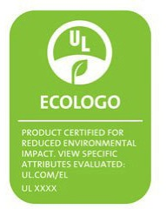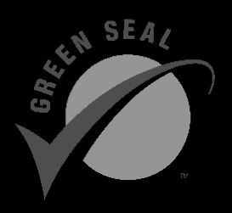
Level 2: Prohibits some asthma-causing chemicals**
Design for the Environment (DfE)
DfE’s criteria prohibit chemicals that may cause cancer or have developmental, reproductive,
or neurotoxicity issues and limit some asthma-causing agents. For a list of products,
visit: http://www.epa.gov/dfe/products
Design for the Environment Antimicrobial Pesticide Pilot Project
Labels environmentally preferred disinfectants. DfE’s criteria prohibit chemicals that may cause cancer, endocrine disruption, and are unlikely to cause developmental, reproductive, mutagenic, or neurotoxicity issues. Prohibits sodium hypochlorite (bleach) and quaternary ammonium compounds. This is the only labeling program available for disinfectants.
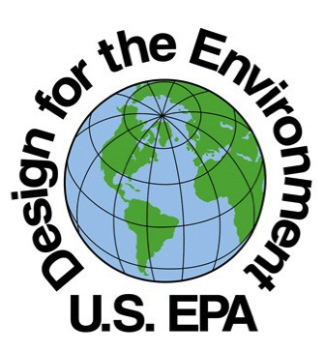
Level 3: Do not prohibit asthma-causing chemicals. May still be a healthier choice than uncertified products.
Carpet and Rug Institute products help limit or get rid of asthma triggers
Green Label Plus
Tests VOC emission levels for carpet and adhesive products for a variety of chemicals. Does NOT prohibit ingredients that cause asthma. This is the only labeling program for carpets and adhesives.
Seal of Approval for Residential Use Vacuums
Measures soil removal, dust containment, and surface appearance change. This is the only labeling program for vacuums.
These third-party certified products may contain ingredients that cause asthma. However, they do not contain ingredients that are known to cause cancer or reproductive harm, and they contain fewer VOCs and cause less pollution.
Green Seal GS-8: Cleaning Products for Household Use
Green Seal GS-34: Cleaning and Degreasing Agents
Green Seal GS-40: Floor-Care Products for Industrial and Institutional Use
UL ECOLOGO UL 2767: Paint and Varnish Removers
UL ECOLOGO UL 2792: Biologically-Based Cleaning and Degreasing Compounds
UL ECOLOGO UL 2777: Hard Floor Care Products
UL ECOLOGO UL 2780: Urinal Blocks

*UL ECOLOGO prohibits asthmagens that cause allergic-type asthma.Green Seal allows the use of enzymes, which can cause allergic-type asthma.WRAPP recommends only Green Seal certified products that do not contain enzymes.
**Prohibits some asthmagens that can cause allergic-type asthma
Training
GHAC practices provide proper training of custodians in the hazards, use, proper dilution, safety, maintenance, and disposal of cleaning chemicals, dispensing equipment, and packaging.
Storage Procedures
Many cleaning products arrive in concentrated form that may require special handling, storage, and disposal. Staff must plan for the physically-isolated storage, safe usage, and proper disposal of cleaning agents and other hazardous chemicals that cannot be eliminated from school buildings and grounds.
Education
Staff, students, custodians, and the school community will be educated about the GHAC policy and procedures. Custodial staff, administrators, teachers, students, vendors, and visitors can learn about what they can do to promote a healthy school environment, such as maintaining uncluttered classrooms and workspaces, and handling spills properly.
This sample is adapted from a sample policy developed by the Healthy Schools Campaign:
http://www.healthyschoolscampaign.org/programs/gcs/guide2/media/documents-forms/policy_draft_9_29_05.doc

